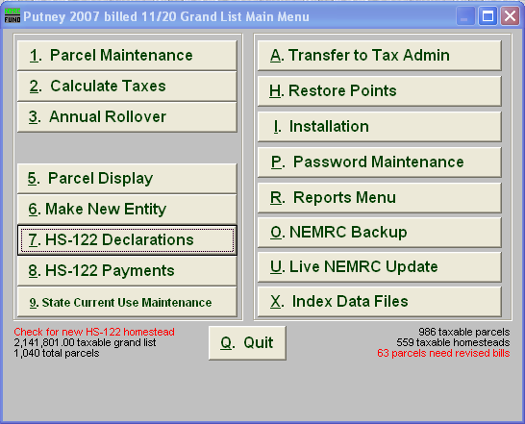
Late Late filers have to be kept track of closely for reconciling Remember, the late late bill has to be compared to the original bill that was sent to the taxpayer. Then the program prints which ever bill has a higher tax due. Therefore, to reconcile between your original tax book and your current tax book it is very important to keep track of who declared a Late Late HS – 122. Below describes how you can print a list of everyone that declared a late late hs 122.

In the As Billed grand list select #7 HS – 122 Declarations.

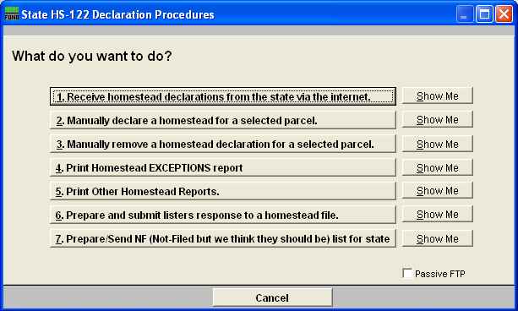

2. Select #Print other Homestead Reports

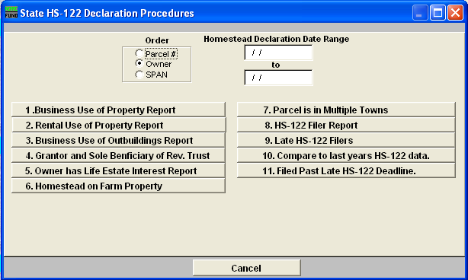

3. Next choose # 11 Filed past Late HS – 122 Deadline. Remember this date was -07/15 in 2006 and was changed to 09/04 in 2007. This report will show you everyone in the grand list that has been flagged as a late late filer.

